Weekly Project Report

25 September, 2018

Team 14: Brandon Christler, Michael Hitchcock, Garrett Monast, Yifan Wu

TrailBot

**Progress**

* Most primary components obtained: Arduino Uno, motor shield, motors, chassis, ultrasonic/IR sensors.
* Model chassis assembled.
* Rudimentary code developed; motors run, ultrasonic sensor data collects (separately).

**Plans**

* Research into Electronics Speed Controllers (ESCs) will be done, and consideration will be made to replace the motor shield with two or four ESCs.
* Further develop code to make bot move while *stopping for* obstacles (circumnavigation will come later).
* Research into IR tracking for bot.
* Incorporate better battery solution for model (likely 6-AA batteries until more appropriate batteries can be obtained).

**Issues**

* Current motor driver (full shield) takes up most of the pins on the Arduino, and makes “extra” pins unavailable. Modification can be done to resolve this, but ESCs would not pose this problem.
* 9V batteries do not draw sufficient current to power motors, so larger batteries will be needed (i.e. batteries capable of discharging more current).

**Schedule**

|  |  |  |  |  |  |  |  |  |  |  |  |  |  |  |  |  |
| --- | --- | --- | --- | --- | --- | --- | --- | --- | --- | --- | --- | --- | --- | --- | --- | --- |
|  | Week 1 | Week 2 | Week 3 | Week 4 | Week 5 | Week 6 | Week 7 | Week 8 | Week 9 | Week 10 | Week 11 | Week 12 | Week 13 | Week 14 | Week 15 | Week 16 |
|  | 21-Aug | 27-Aug | 3-Sep | 10-Sep | 17-Sep | 24-Sep | 1-Oct | 8-Oct | 15-Oct | 22-Oct | 29-Oct | 5-Nov | 12-Nov | 19-Nov | 26-Nov | 3-Dec |
| Design |  |  |  |  |  |  |  |  |  |  |  |  |  |  |  |  |
| Chassis |  |  |  |  |  |  |  |  |  |  |  |  |  |  |  |  |
| Controller |  |  |  |  |  |  |  |  |  |  |  |  |  |  |  |  |
| Software |  |  |  |  |  |  |  |  |  |  |  |  |  |  |  |  |
| Sensors |  |  |  |  |  |  |  |  |  |  |  |  |  |  |  |  |
| Additional Functions |  |  |  |  |  |  |  |  |  |  |  |  |  |  |  |  |
| Build |  |  |  |  |  |  |  |  |  |  |  |  |  |  |  |  |
| Chassis |  |  |  |  |  |  |  |  |  |  |  |  |  |  |  |  |
| Controller |  |  |  |  |  |  |  |  |  |  |  |  |  |  |  |  |
| Sensors |  |  |  |  |  |  |  |  |  |  |  |  |  |  |  |  |
| Test |  |  |  |  |  |  |  |  |  |  |  |  |  |  |  |  |
| Ability to move |  |  |  |  |  |  |  |  |  |  |  |  |  |  |  |  |
| Ability to follow |  |  |  |  |  |  |  |  |  |  |  |  |  |  |  |  |
| Obstacle detection |  |  |  |  |  |  |  |  |  |  |  |  |  |  |  |  |
| Additional Functions |  |  |  |  |  |  |  |  |  |  |  |  |  |  |  |  |
| Present |  |  |  |  |  |  |  |  |  |  |  |  |  |  |  |  |
| Compile Documentation |  |  |  |  |  |  |  |  |  |  |  |  |  |  |  |  |
| Create Presentation |  |  |  |  |  |  |  |  |  |  |  |  |  |  |  |  |

**Figures**

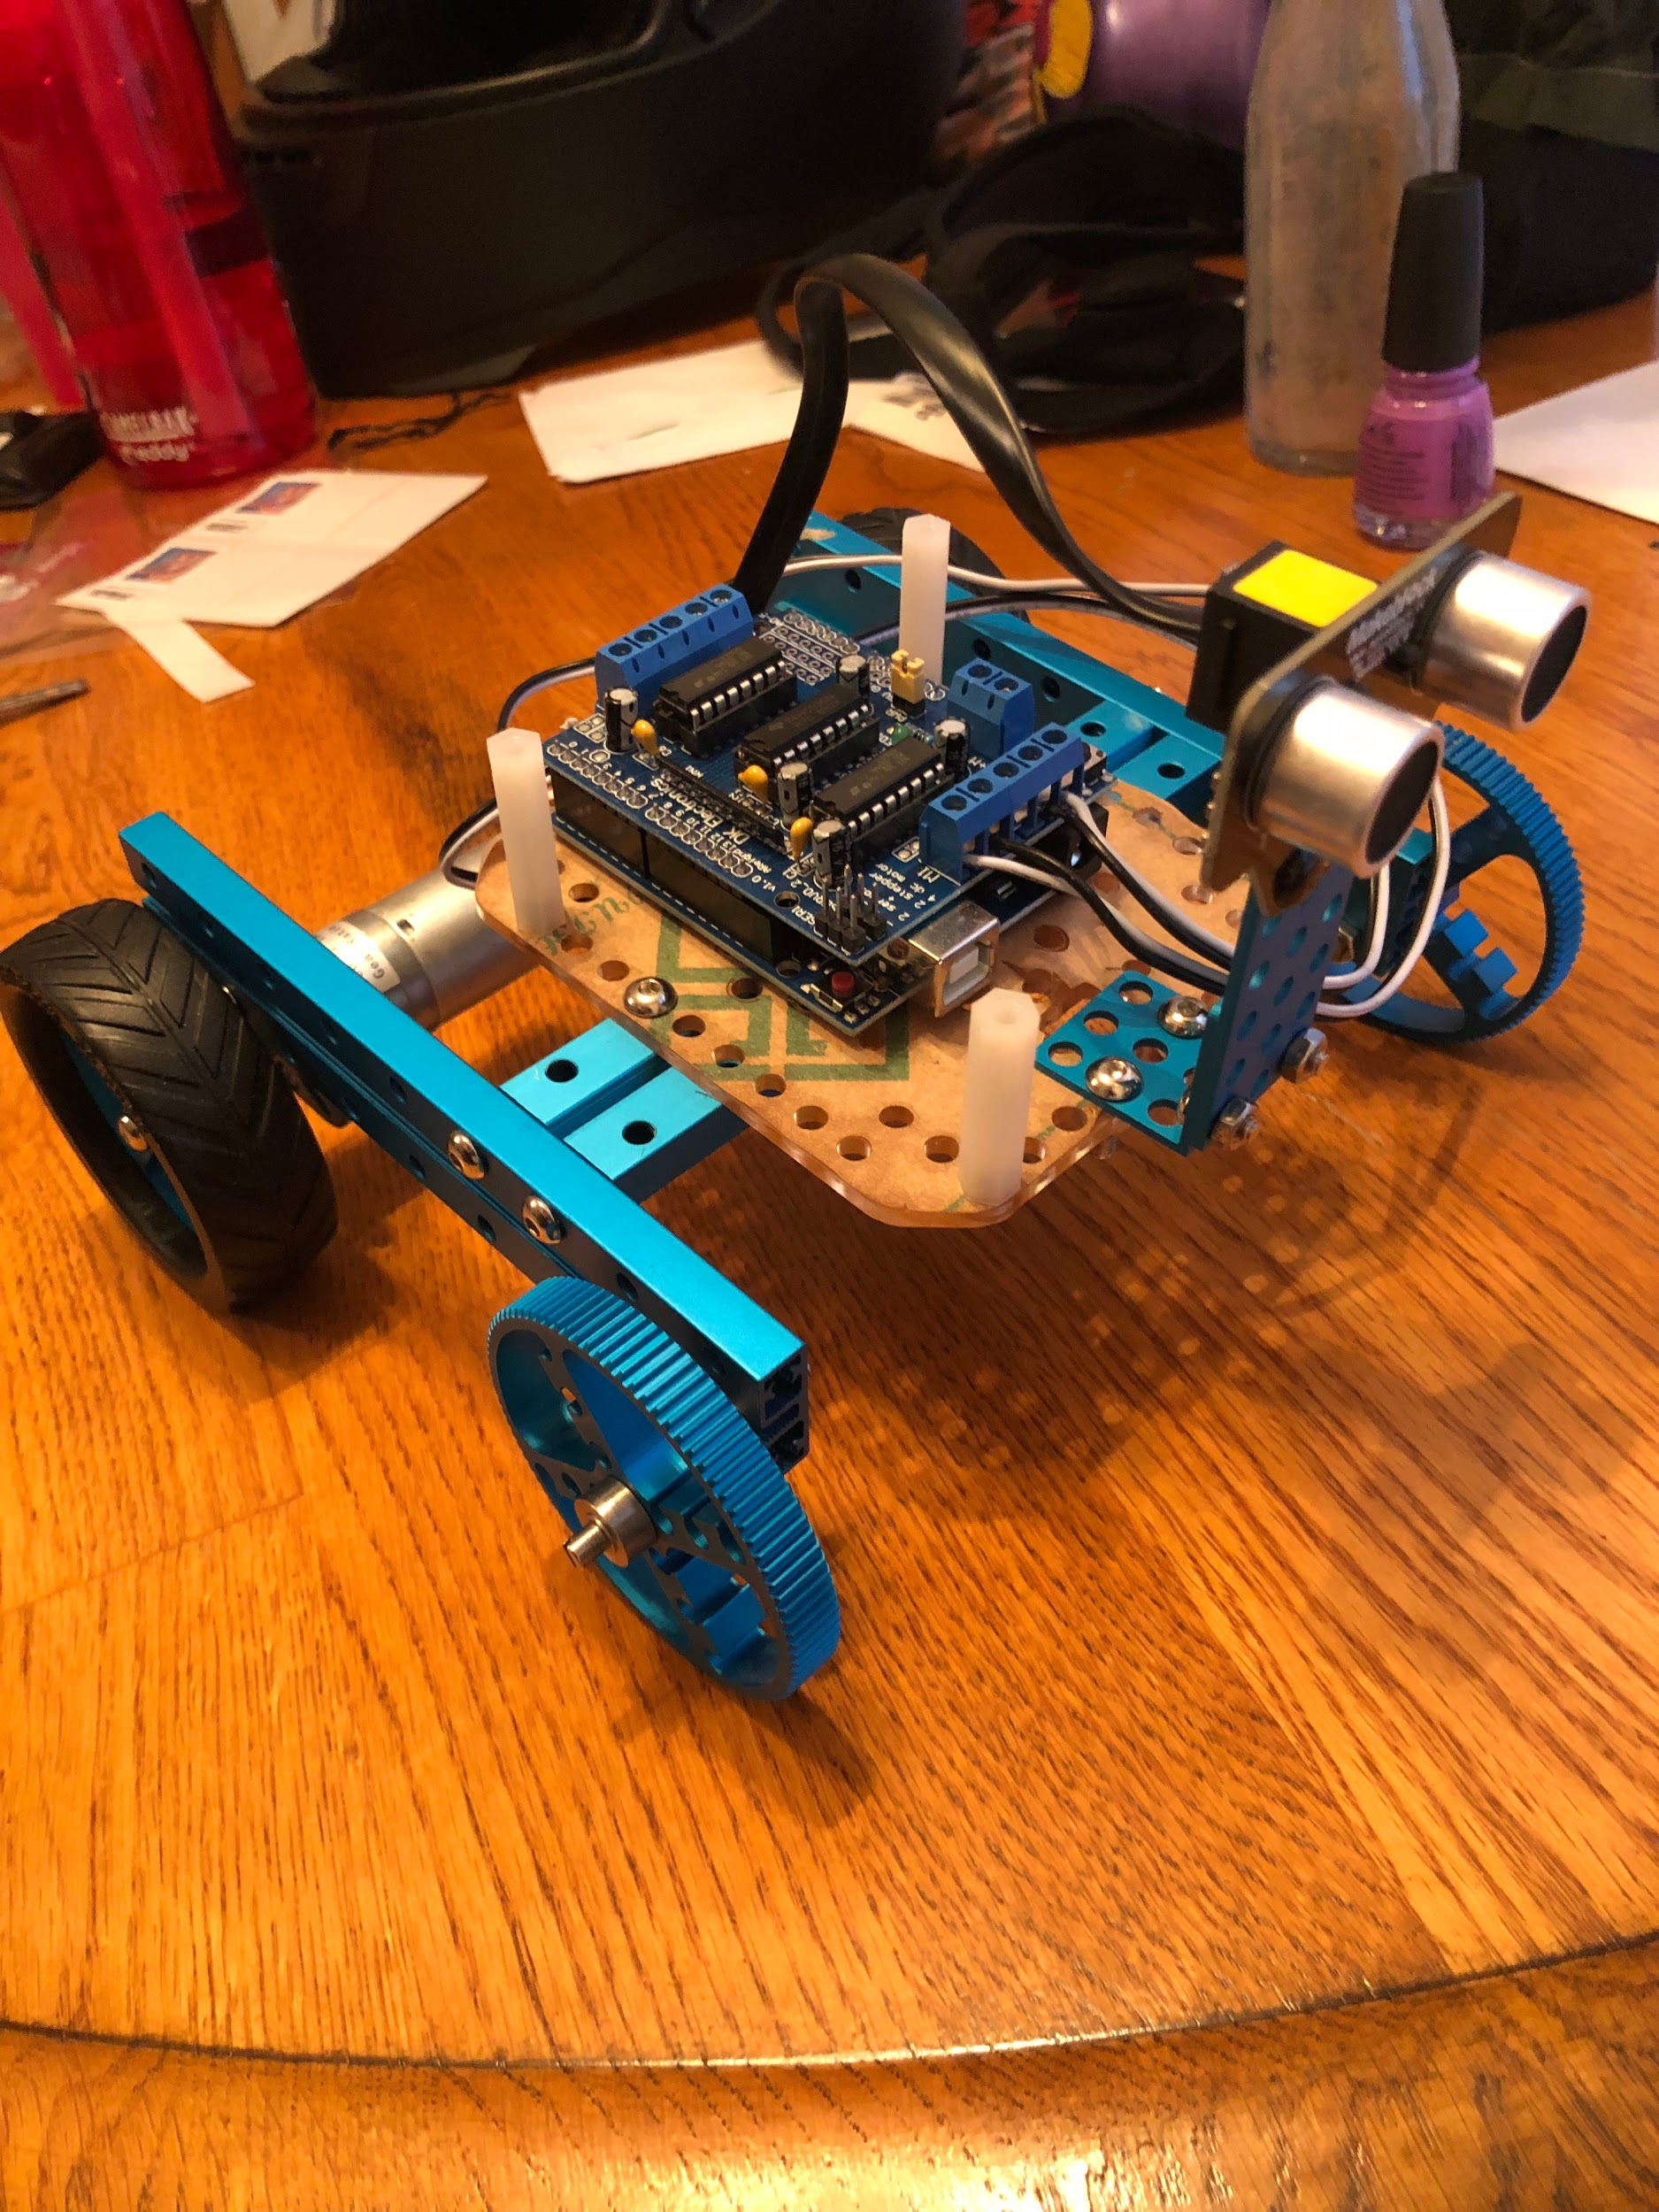

Assembled Model Chassis with Uno, Motor Shield, and Ultrasonic Sensor